Experiment 2: Visualization of COVID-19 Data
Introduction:
This experiment demonstrates how to visualize COVID-19 trends in the United States using Python’s Pandas, Matplotlib, and Seaborn libraries
Data Preparation
- Load the Dataset and Convert Date Format:
  - The dataset is loaded using pd.read_csv().
  - The ‘Date’ column is converted to a datetime format for proper plotting.
- Handle Missing Data:
  - Missing values in the ‘Recovered’ column are filled with 0.
- Filter and Aggregate Data for the US:
  - Data is filtered where Country/Region == 'US'.
  - Data is grouped by date to aggregate Confirmed, Deaths, and Recovered cases.
Code:
import pandas as pd
import matplotlib.pyplot as plt
import seaborn as sns

# Load the COVID-19 dataset
file_path = "/content/time-series-19-covid-combined.csv" # Update with your file path if needed
data = pd.read_csv(file_path)

# Convert the 'Date' column to datetime format
data['Date'] = pd.to_datetime(data['Date'])

# Fill missing values in 'Recovered' with 0
data['Recovered'].fillna(0, inplace=True)

# Filter the dataset for the United States
country_data = data[data['Country/Region'] == 'US']

# Aggregate data by date (in case there are province/state-level details)
country_data = country_data.groupby('Date')[['Confirmed', 'Deaths', 'Recovered']].sum().reset_index()

COVID-19 Confirmed Cases Over Time (US):
plt.figure(figsize=(12, 6))
sns.lineplot(x='Date', y='Confirmed', data=country_data, label='Confirmed Cases', color='blue')
plt.title('COVID-19 Confirmed Cases Over Time - US')
plt.xlabel('Date')
plt.ylabel('Number of Cases')
plt.xticks(rotation=45)
plt.grid(True)
plt.show()
Explanation:
This line plot visualizes the trend of confirmed COVID-19 cases in the US. The x-axis represents the date, while the y-axis shows the cumulative number of confirmed cases

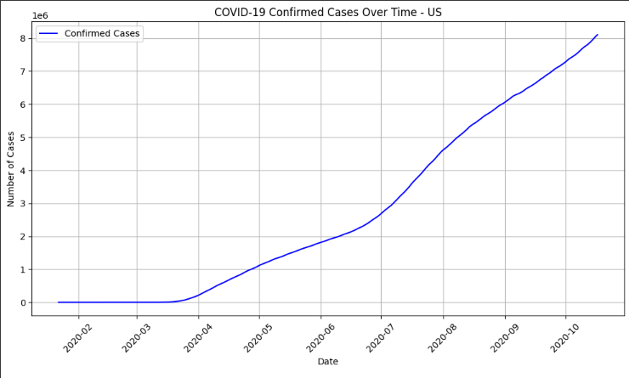

COVID-19 Deaths Over Time (US):
plt.figure(figsize=(12, 6))
sns.lineplot(x='Date', y='Deaths', data=country_data, label='Deaths',
color='red')
plt.title('COVID-19 Deaths Over Time - US')
plt.xlabel('Date')
plt.ylabel('Number of Deaths')
plt.xticks(rotation=45)
plt.grid(True)
plt.show()
Explanation:
This plot displays the trend of COVID-19 related deaths in the US. The x-axis shows the date, and the y-axis shows the cumulative number of deaths.
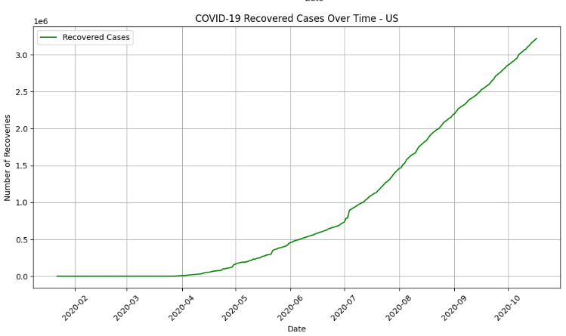

COVID-19 Recovered Cases Over Time (US):
plt.figure(figsize=(12, 6))
sns.lineplot(x='Date', y='Recovered', data=country_data, label='Recovered Cases', color='green')
plt.title('COVID-19 Recovered Cases Over Time - US')
plt.xlabel('Date')
plt.ylabel('Number of Recoveries')
plt.xticks(rotation=45)
plt.grid(True)
plt.show()

Explanation:
This line plot shows the progression of recovered COVID-19 cases in the US. The x-axis represents the date, and the y-axis shows the cumulative number of recoveries.
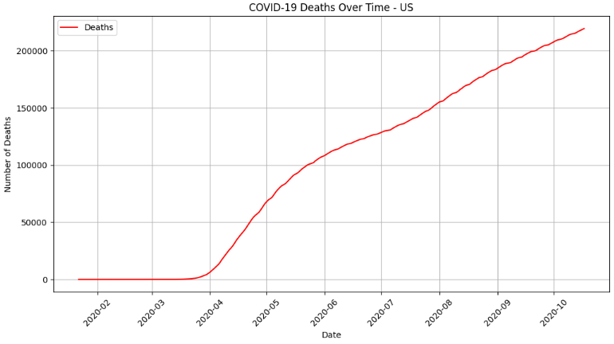

Combined Plot: Confirmed, Deaths, and Recovered Cases Over Time (US):
plt.figure(figsize=(12, 6))
sns.lineplot(x='Date', y='Confirmed', data=country_data, label='Confirmed
Cases', color='blue')
sns.lineplot(x='Date', y='Deaths', data=country_data, label='Deaths',
color='red')
sns.lineplot(x='Date', y='Recovered', data=country_data, label='Recovered Cases', color='green')
plt.title('COVID-19 Confirmed, Deaths, and Recovered Cases Over Time - US')
plt.xlabel('Date')
plt.ylabel('Number of Cases')
plt.xticks(rotation=45)
plt.grid(True)
plt.legend()
plt.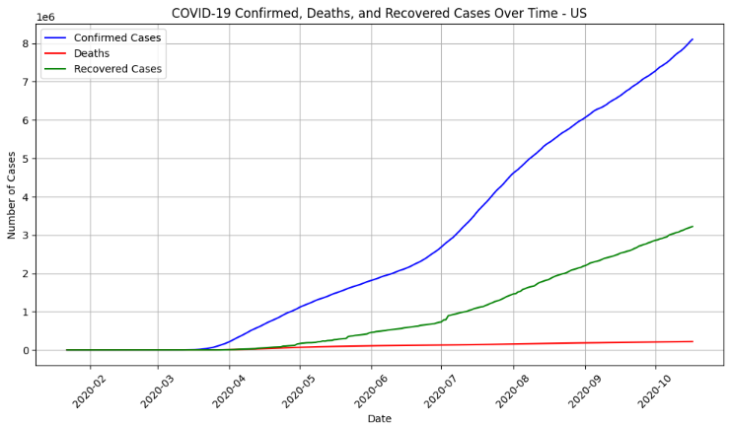Explanation:
This combined plot provides an overview of the COVID-19 situation in the US by illustrating the trends of confirmed cases, deaths, and recoveries over time on the same graph.

Result:
Thus the visualization techniques in Time Series Analysis and Forecasting has been studied successfully

